**02 ДЗ - Развертывание и базовая конфигурация, интерфейсы и инструменты.**

**Собираем Dockerfile для clickhouse.**

Dockerfile:  
  
FROM clickhouse/clickhouse-server:25.2.1   
MAINTAINER Maksim Kulikov [max.uoles@rambler.ru](mailto:max.uoles@rambler.ru)  
  
RUN apt-get update -y --fix-missing   
RUN DEBIAN_FRONTEND=noninteractive apt-get -yq upgrade  
RUN apt-get install nano mc python3 pip kafkacat –y  
RUN pip install clickhouse_driver  
  
EXPOSE 8123 9000  
ENTRYPOINT ["/entrypoint.sh"]

Собираем образ командой:

docker build -t uoles/clickhouse:25.2.1 .

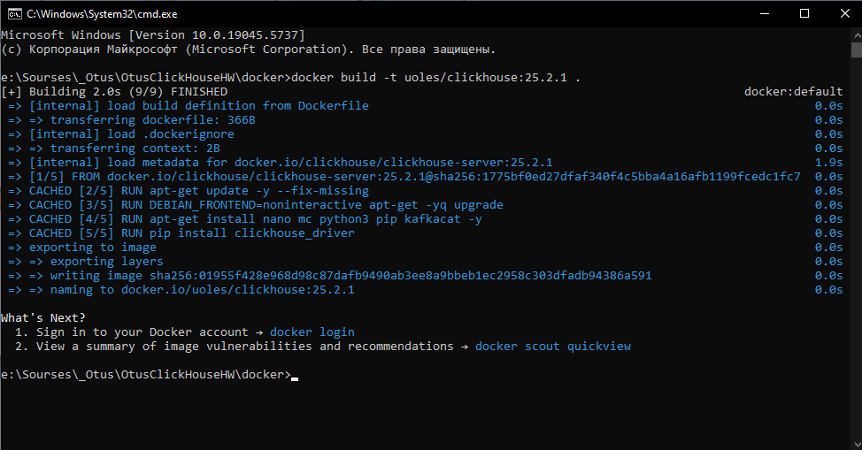

Запускаем контейнер командой:

docker run -d

-p 18123:8123

-p 19000:9000

-e CLICKHOUSE_DB=my_database

-e CLICKHOUSE_USER=username

-e CLICKHOUSE_DEFAULT_ACCESS_MANAGEMENT=1

-e CLICKHOUSE_PASSWORD=password

--name clickhouse-server-02

--ulimit nofile=262144:262144

uoles/clickhouse:25.2.1

**Создаем таблицу и заливаем данные.**

Набор тестовых данных брал этот:  
<https://clickhouse.com/docs/ru/getting-started/example-datasets/uk-price-paid>

Создаем таблицу:

CREATE TABLE my_database.uk_price_paid (

price UInt32,

date Date,

postcode1 LowCardinality(String),

postcode2 LowCardinality(String),

type Enum8('terraced' = 1, 'semi-detached' = 2, 'detached' = 3, 'flat' = 4, 'other' = 0),

is_new UInt8,

duration Enum8('freehold' = 1, 'leasehold' = 2, 'unknown' = 0),

addr1 String,

addr2 String,

street LowCardinality(String),

locality LowCardinality(String),

town LowCardinality(String),

district LowCardinality(String),

county LowCardinality(String)

)

ENGINE = MergeTree

ORDER BY (postcode1, postcode2, addr1, addr2);

Вставка данных:

INSERT INTO my_database.uk_price_paid

WITH

splitByChar(' ', postcode) AS p

SELECT

toUInt32(price_string) AS price,

parseDateTimeBestEffortUS(time) AS date,

p[1] AS postcode1,

p[2] AS postcode2,

transform(a, ['T', 'S', 'D', 'F', 'O'], ['terraced', 'semi-detached', 'detached', 'flat', 'other']) AS type,

b = 'Y' AS is_new,

transform(c, ['F', 'L', 'U'], ['freehold', 'leasehold', 'unknown']) AS duration,

addr1,

addr2,

street,

locality,

town,

district,

county

FROM url(

'http://prod.publicdata.landregistry.gov.uk.s3-website-eu-west-1.amazonaws.com/pp-complete.csv',

'CSV',

'uuid_string String,

price_string String,

time String,

postcode String,

a String,

b String,

c String,

addr1 String,

addr2 String,

street String,

locality String,

town String,

district String,

county String,

d String,

e String'

) SETTINGS max_http_get_redirects=10;

Проверяем данные:

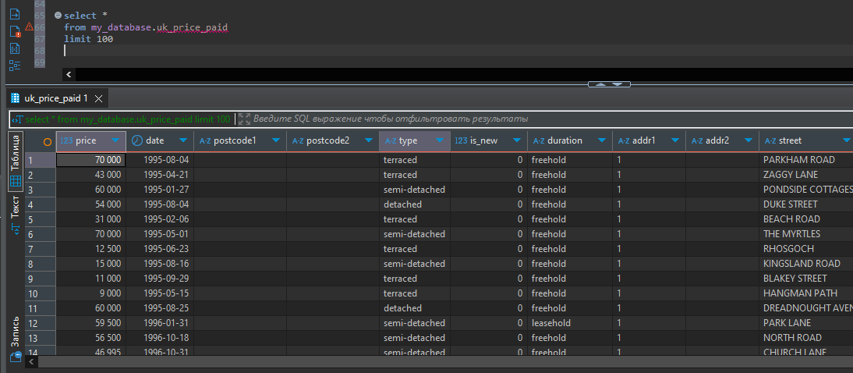

**Запускаем бенчмарк и тестируем производительность.**

Заходим в контейнер:  
docker exec -it clickhouse-server-02 bash

Тестируем командой:  
clickhouse-benchmark --user username --password password -i 10 --query "SELECT * FROM my_database.uk_price_paid LIMIT 6000000 OFFSET 6000000"

Результат без настроек (дефолтные):

Loaded 1 queries.

Queries executed: 2.

localhost:9000, queries: 2, QPS: 1.951, RPS: 23433605.734, MiB/s: 991.244, result RPS: 11707561.698, result MiB/s: 462.173.

0% 0.498 sec.

10% 0.498 sec.

20% 0.498 sec.

30% 0.498 sec.

40% 0.498 sec.

50% 0.518 sec.

60% 0.518 sec.

70% 0.518 sec.

80% 0.518 sec.

90% 0.518 sec.

95% 0.518 sec.

99% 0.518 sec.

99.9% 0.518 sec.

99.99% 0.518 sec.

Queries executed: 5.

localhost:9000, queries: 3, QPS: 2.073, RPS: 24883216.753, MiB/s: 1052.425, result RPS: 12437451.504, result MiB/s: 490.469.

0% 0.475 sec.

10% 0.475 sec.

20% 0.475 sec.

30% 0.480 sec.

40% 0.480 sec.

50% 0.480 sec.

60% 0.480 sec.

70% 0.480 sec.

80% 0.482 sec.

90% 0.482 sec.

95% 0.482 sec.

99% 0.482 sec.

99.9% 0.482 sec.

99.99% 0.482 sec.

Queries executed: 8.

localhost:9000, queries: 3, QPS: 2.080, RPS: 24978178.971, MiB/s: 1056.884, result RPS: 12482077.332, result MiB/s: 492.505.

0% 0.476 sec.

10% 0.476 sec.

20% 0.476 sec.

30% 0.476 sec.

40% 0.476 sec.

50% 0.476 sec.

60% 0.476 sec.

70% 0.476 sec.

80% 0.481 sec.

90% 0.481 sec.

95% 0.481 sec.

99% 0.481 sec.

99.9% 0.481 sec.

99.99% 0.481 sec.

Queries executed: 10.

localhost:9000, queries: 10, QPS: 2.005, RPS: 24072092.014, MiB/s: 1018.304, result RPS: 12030656.273, result MiB/s: 474.575.

0% 0.475 sec.

10% 0.476 sec.

20% 0.476 sec.

30% 0.480 sec.

40% 0.480 sec.

50% 0.481 sec.

60% 0.481 sec.

70% 0.482 sec.

80% 0.483 sec.

90% 0.498 sec.

95% 0.518 sec.

99% 0.518 sec.

99.9% 0.518 sec.

99.99% 0.518 sec.

Выставил ограничение памяти - 2GB

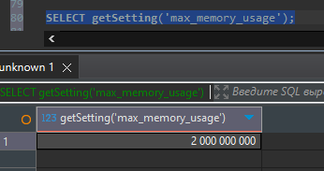

Loaded 1 queries.

Queries executed: 2.

localhost:9000, queries: 2, QPS: 1.957, RPS: 23499118.293, MiB/s: 994.561, result RPS: 11744297.701, result MiB/s: 463.163.

0% 0.488 sec.

10% 0.488 sec.

20% 0.488 sec.

30% 0.488 sec.

40% 0.488 sec.

50% 0.523 sec.

60% 0.523 sec.

70% 0.523 sec.

80% 0.523 sec.

90% 0.523 sec.

95% 0.523 sec.

99% 0.523 sec.

99.9% 0.523 sec.

99.99% 0.523 sec.

Queries executed: 5.

localhost:9000, queries: 3, QPS: 2.073, RPS: 24884154.369, MiB/s: 1052.017, result RPS: 12437920.155, result MiB/s: 490.488.

0% 0.474 sec.

10% 0.474 sec.

20% 0.474 sec.

30% 0.480 sec.

40% 0.480 sec.

50% 0.480 sec.

60% 0.480 sec.

70% 0.480 sec.

80% 0.483 sec.

90% 0.483 sec.

95% 0.483 sec.

99% 0.483 sec.

99.9% 0.483 sec.

99.99% 0.483 sec.

Queries executed: 8.

localhost:9000, queries: 3, QPS: 2.066, RPS: 24805128.840, MiB/s: 1049.538, result RPS: 12398420.592, result MiB/s: 489.094.

0% 0.475 sec.

10% 0.475 sec.

20% 0.475 sec.

30% 0.478 sec.

40% 0.478 sec.

50% 0.478 sec.

60% 0.478 sec.

70% 0.478 sec.

80% 0.488 sec.

90% 0.488 sec.

95% 0.488 sec.

99% 0.488 sec.

99.9% 0.488 sec.

99.99% 0.488 sec.

Queries executed: 10.

localhost:9000, queries: 10, QPS: 2.005, RPS: 24069096.883, MiB/s: 1018.102, result RPS: 12030801.248, result MiB/s: 474.406.

0% 0.474 sec.

10% 0.475 sec.

20% 0.476 sec.

30% 0.478 sec.

40% 0.480 sec.

50% 0.481 sec.

60% 0.481 sec.

70% 0.483 sec.

80% 0.488 sec.

90% 0.488 sec.

95% 0.523 sec.

99% 0.523 sec.

99.9% 0.523 sec.

99.99% 0.523 sec.

Ограничение параллельных запросов на пользователя – 1.

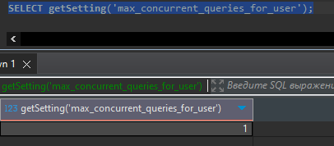

Loaded 1 queries.

Queries executed: 2.

localhost:9000, queries: 2, QPS: 1.984, RPS: 23849595.434, MiB/s: 1008.369, result RPS: 11903213.224, result MiB/s: 468.369.

0% 0.479 sec.

10% 0.479 sec.

20% 0.479 sec.

30% 0.479 sec.

40% 0.479 sec.

50% 0.520 sec.

60% 0.520 sec.

70% 0.520 sec.

80% 0.520 sec.

90% 0.520 sec.

95% 0.520 sec.

99% 0.520 sec.

99.9% 0.520 sec.

99.99% 0.520 sec.

Queries executed: 5.

localhost:9000, queries: 3, QPS: 2.074, RPS: 24891373.791, MiB/s: 1052.458, result RPS: 12441528.660, result MiB/s: 490.500.

0% 0.473 sec.

10% 0.473 sec.

20% 0.473 sec.

30% 0.482 sec.

40% 0.482 sec.

50% 0.482 sec.

60% 0.482 sec.

70% 0.482 sec.

80% 0.482 sec.

90% 0.482 sec.

95% 0.482 sec.

99% 0.482 sec.

99.9% 0.482 sec.

99.99% 0.482 sec.

Queries executed: 8.

localhost:9000, queries: 3, QPS: 2.084, RPS: 25022156.332, MiB/s: 1058.069, result RPS: 12504053.667, result MiB/s: 492.652.

0% 0.472 sec.

10% 0.472 sec.

20% 0.472 sec.

30% 0.476 sec.

40% 0.476 sec.

50% 0.476 sec.

60% 0.476 sec.

70% 0.476 sec.

80% 0.481 sec.

90% 0.481 sec.

95% 0.481 sec.

99% 0.481 sec.

99.9% 0.481 sec.

99.99% 0.481 sec.

Queries executed: 10.

localhost:9000, queries: 10, QPS: 2.017, RPS: 24220080.665, MiB/s: 1024.267, result RPS: 12102140.056, result MiB/s: 476.929.

0% 0.472 sec.

10% 0.473 sec.

20% 0.475 sec.

30% 0.476 sec.

40% 0.479 sec.

50% 0.479 sec.

60% 0.479 sec.

70% 0.481 sec.

80% 0.482 sec.

90% 0.482 sec.

95% 0.520 sec.

99% 0.520 sec.

99.9% 0.520 sec.

99.99% 0.520 sec.

Ограничение потоков – 1

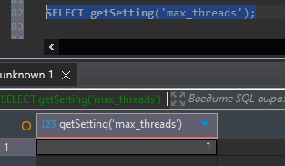

Loaded 1 queries.

Queries executed: 2.

localhost:9000, queries: 2, QPS: 1.506, RPS: 18105512.605, MiB/s: 755.584, result RPS: 9033292.568, result MiB/s: 352.058.

0% 0.660 sec.

10% 0.660 sec.

20% 0.660 sec.

30% 0.660 sec.

40% 0.660 sec.

50% 0.664 sec.

60% 0.664 sec.

70% 0.664 sec.

80% 0.664 sec.

90% 0.664 sec.

95% 0.664 sec.

99% 0.664 sec.

99.9% 0.664 sec.

99.99% 0.664 sec.

Queries executed: 4.

localhost:9000, queries: 2, QPS: 1.519, RPS: 18269401.820, MiB/s: 762.423, result RPS: 9115060.992, result MiB/s: 355.245.

0% 0.652 sec.

10% 0.652 sec.

20% 0.652 sec.

30% 0.652 sec.

40% 0.652 sec.

50% 0.662 sec.

60% 0.662 sec.

70% 0.662 sec.

80% 0.662 sec.

90% 0.662 sec.

95% 0.662 sec.

99% 0.662 sec.

99.9% 0.662 sec.

99.99% 0.662 sec.

Queries executed: 6.

localhost:9000, queries: 2, QPS: 1.550, RPS: 18637197.230, MiB/s: 777.772, result RPS: 9298563.311, result MiB/s: 362.396.

0% 0.643 sec.

10% 0.643 sec.

20% 0.643 sec.

30% 0.643 sec.

40% 0.643 sec.

50% 0.646 sec.

60% 0.646 sec.

70% 0.646 sec.

80% 0.646 sec.

90% 0.646 sec.

95% 0.646 sec.

99% 0.646 sec.

99.9% 0.646 sec.

99.99% 0.646 sec.

Queries executed: 8.

localhost:9000, queries: 2, QPS: 1.542, RPS: 18546556.039, MiB/s: 773.989, result RPS: 9253340.156, result MiB/s: 360.634.

0% 0.640 sec.

10% 0.640 sec.

20% 0.640 sec.

30% 0.640 sec.

40% 0.640 sec.

50% 0.655 sec.

60% 0.655 sec.

70% 0.655 sec.

80% 0.655 sec.

90% 0.655 sec.

95% 0.655 sec.

99% 0.655 sec.

99.9% 0.655 sec.

99.99% 0.655 sec.

Queries executed: 10.

localhost:9000, queries: 10, QPS: 1.505, RPS: 18102791.404, MiB/s: 755.470, result RPS: 9031934.893, result MiB/s: 352.005.

0% 0.640 sec.

10% 0.643 sec.

20% 0.646 sec.

30% 0.650 sec.

40% 0.652 sec.

50% 0.655 sec.

60% 0.655 sec.

70% 0.656 sec.

80% 0.660 sec.

90% 0.662 sec.

95% 0.664 sec.

99% 0.664 sec.

99.9% 0.664 sec.

99.99% 0.664 sec.

Изменение памяти в целом не повлияло на результаты, что 2GB, что 200MB. Повлияло ограничение кол-ва параллельных запросов и потоков – показатели ухудшились.

